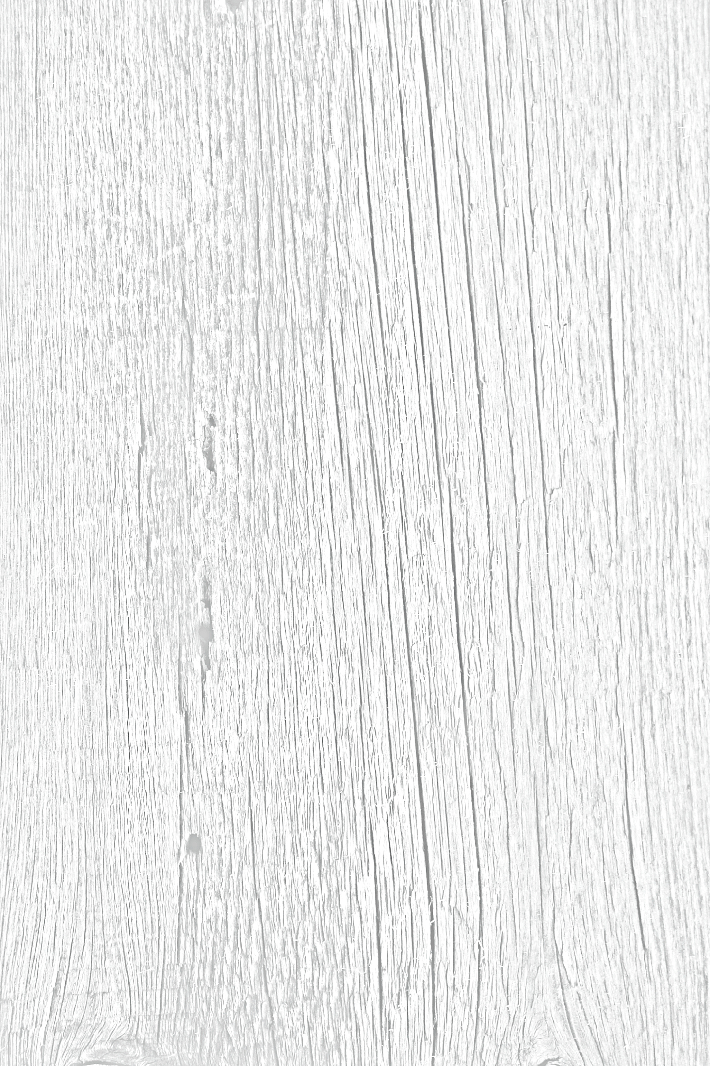

Type your text here. Position text box where desired on the wood background. Choose desired font style & font size